Lab2 Current mirror
Object: The current source is a basic building block in CMOS IC design and is used extensively in analog integrated circuit design. PSIPCE and BSIM3 model is introduced in this lab to simulate a current mirror.
Introduction: We are going to using BSIM3 model for N,P MOSFET in PSPICE circuit simulation.

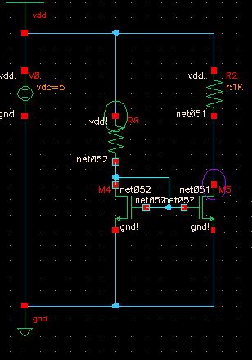
This is a circuit of current sink.
Before simulation,calculate:
If you want to get Id(M4)=10uA,Id(M5)=20uA, R0=? M4 W/L= ?/2um M/L=?/2um

Project:
Using Pspice to simulation the current mirror with Id=20uA.
Steps:
A. Edit a netlist file for the circuit.
Use text edit tools such as WORDPAD, edit a netlist file.Example

R0 100 101 100E3
V4 102 0 2.5
V0 100 102 2.5
M5 101 101 0 0 AMI06N L=4.95E-6 W=15E-6 AD=22.5E-12 AS=22.5E-12 PD=33E-6
+PS=33E-6 M=1
M4 102 101 0 0 AMI06N L=4.95E-6 W=30E-6 AD=45E-12 AS=45E-12 PD=63E-6 PS=63E-6
+M=1
* level 11 for Cadence Spectre
* DATE: Jan 25/99
* LOT: n8bn WAF: 03
* Temperature_parameters=Default
* Include files
* End of Netlist
* Model File
.MODEL AMI06N NMOS (Level= 7
+Tnom=27.0
+Nch= 2.498E+17 Tox=9E-09 Xj=1.00000E-07
+Lint=9.36e-8 Wint=1.47e-7
+Vth0= .6322 K1= .756 K2= -3.83e-2 K3= -2.612
+Dvt0= 2.812 Dvt1= 0.462 Dvt2=-9.17e-2
+Nlx= 3.52291E-08 W0= 1.163e-6
+K3b= 2.233
+Vsat= 86301.58 Ua= 6.47e-9 Ub= 4.23e-18 Uc=-4.706281E-11
+Rdsw= 650 U0= 388.3203 wr=1
+A0= .3496967 Ags=.1 B0=0.546 B1= 1
+ Dwg = -6.0E-09 Dwb = -3.56E-09 Prwb = -.213
+Keta=-3.605872E-02 A1= 2.778747E-02 A2= .9
+Voff=-6.735529E-02 NFactor= 1.139926 Cit= 1.622527E-04
+Cdsc=-2.147181E-05
+Cdscb= 0 Dvt0w = 0 Dvt1w = 0 Dvt2w = 0
+ Cdscd = 0 Prwg = 0
+Eta0= 1.0281729E-02 Etab=-5.042203E-03
+Dsub= .31871233
+Pclm= 1.114846 Pdiblc1= 2.45357E-03 Pdiblc2= 6.406289E-03
+Drout= .31871233 Pscbe1= 5000000 Pscbe2= 5E-09 Pdiblcb = -.234
+Pvag= 0 delta=0.01
+ Wl = 0 Ww = -1.420242E-09 Wwl = 0
+ Wln = 0 Wwn = .2613948 Ll = 1.300902E-10
+ Lw = 0 Lwl = 0 Lln = .316394
+ Lwn = 0
+kt1=-.3 kt2=-.051
+At= 22400
+Ute=-1.48
+Ua1= 3.31E-10 Ub1= 2.61E-19 Uc1= -3.42e-10
+Kt1l=0 Prt=764.3
+L=1.05e-6 W=10.9e-6 )
*end of model file

.probe
.DC V4
+ 2.500000E+00 2.510000E+00 1.000000E-02
.TEMP 0.2500E+02
.OP

.END

Save the file as Lab2test.cir

B. Open Pspice AD 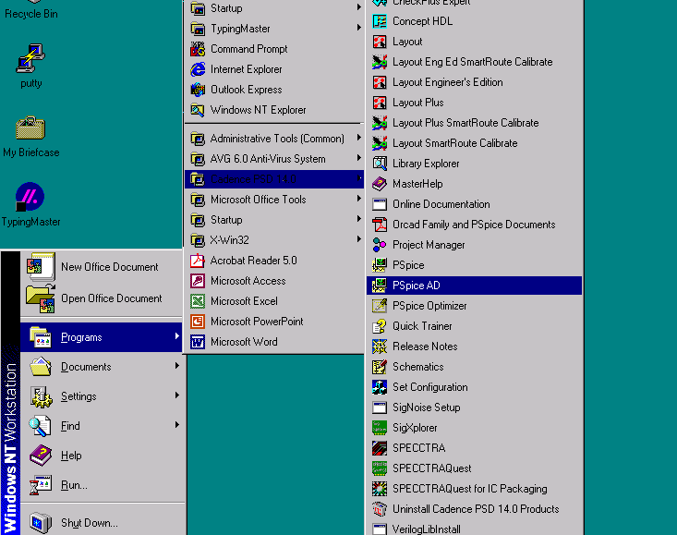

C. Load file lab2test.cir
D. Simulation>Run
E. Trace>Add trace select the Id
You get
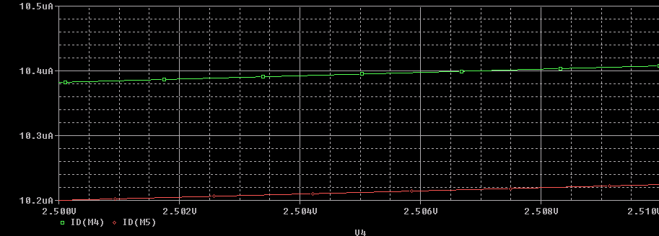

Now you are ready to edit your file. You need change the R ,L and W of transistors so as to make Id(M4)=10uA,Id(M5)=20uA
Also you need replace the Model file of NMOS with the BSIM3 model.

.model N1 NMOS
+Level= 7
+Tnom=27.0
+Nch= 2.498E+17 Tox=9E-09 Xj=1.00000E-07
+Lint=9.36e-8 Wint=1.47e-7
+Vth0= .6322 K1= .756 K2= -3.83e-2 K3= -2.612
+Dvt0= 2.812 Dvt1= 0.462 Dvt2=-9.17e-2
+Nlx= 3.52291E-08 W0= 1.163e-6
+K3b= 2.233
+Vsat= 86301.58 Ua= 6.47e-9 Ub= 4.23e-18 Uc=-4.706281E-11
+Rdsw= 650 U0= 388.3203 wr=1
+A0= .3496967 Ags=.1 B0=0.546 B1= 1
+ Dwg = -6.0E-09 Dwb = -3.56E-09 Prwb = -.213
+Keta=-3.605872E-02 A1= 2.778747E-02 A2= .9
+Voff=-6.735529E-02 NFactor= 1.139926 Cit= 1.622527E-04
+Cdsc=-2.147181E-05
+Cdscb= 0 Dvt0w = 0 Dvt1w = 0 Dvt2w = 0
+ Cdscd = 0 Prwg = 0
+Eta0= 1.0281729E-02 Etab=-5.042203E-03
+Dsub= .31871233
+Pclm= 1.114846 Pdiblc1= 2.45357E-03 Pdiblc2= 6.406289E-03
+Drout= .31871233 Pscbe1= 5000000 Pscbe2= 5E-09 Pdiblcb = -.234
+Pvag= 0 delta=0.01
+ Wl = 0 Ww = -1.420242E-09 Wwl = 0
+ Wln = 0 Wwn = .2613948 Ll = 1.300902E-10
+ Lw = 0 Lwl = 0 Lln = .316394
+ Lwn = 0
+kt1=-.3 kt2=-.051
+At= 22400
+Ute=-1.48
+Ua1= 3.31E-10 Ub1= 2.61E-19 Uc1= -3.42e-10
+Kt1l=0 Prt=764.3

